|  |  |
| --- | --- |
| **ASSIGNMENT COVER SHEET** | **ANU College of Engineering, Computing and Cybernetics** Australian National University Canberra ACT 0200 Australia **www.anu.edu.au**  **+61 2 6125 5254** |
| Submission and assessment is anonymous where appropriate and possible.  This coversheet must be attached to the front of your assessment when submitted in hard copy. If you have elected to submit in hard copy rather than Turnitin, you must provide copies of all references included in the assessment item.  All assessment items submitted in hard copy are due at 5pm unless otherwise specified in the course outline. |

|  |  |  |  |
| --- | --- | --- | --- |
| Student 1 ID |  | | |
| Student 1 Name |  | | |
| Student 2 ID |  | | |
| Student 2 Name |  | | |
| Course Code | ENGN4213/6213 | | |
| Course Name | Digital Systems and Microprocessors | | |
| Assignment Item | FPGA Project Report  Micro-controller Project Report | | |
| Word Count |  | Due Date |  |
| Date Submitted |  | Extension Granted |  |

I declare that this work:

upholds the principles of academic integrity, as defined in the University [Academic Integrity Rule](https://www.legislation.gov.au/Details/F2021L00997);

is original, except where collaboration (for example group work) has been authorised in writing by the course convener in the course outline and/or Wattle site;

is produced for the purposes of this assessment task and has not been submitted for assessment in any other context, except where authorised in writing by the course convener;

gives appropriate acknowledgement of the ideas, scholarship and intellectual property of others insofar as these have been used;

in no part involves copying, cheating, collusion, fabrication, plagiarism or recycling.

|  |  |
| --- | --- |
| **Initials**  For group assignments, each student must initial. |  |

**CONTRIBUTION STATEMENT**

We, the undersigned members of ENGN4213/6213 FPGA Project Group No:_______, hereby state our main individual contributions.

|  |  |
| --- | --- |
|  |  |
| Signature 1 with name  _____________________________  Date: ________________________ | Signature 2 with name  _____________________________  Date: ________________________ |

This statement may be considered to assess fair contributions among group members and, if deemed necessary, regulate individual marking.

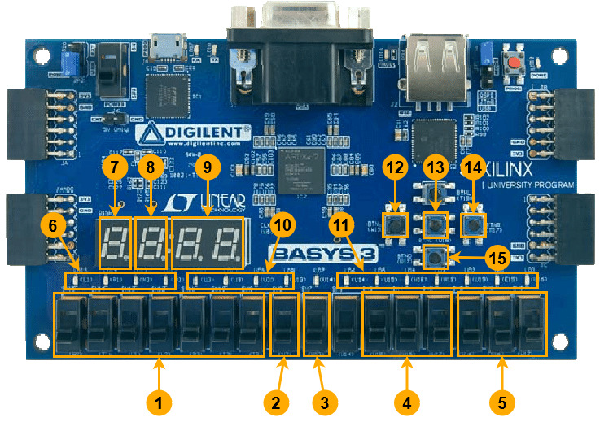

|  |  |
| --- | --- |
| Label | Component Description |
| 1 | Slide switches to input the 7-digit binary pin for vault access. |
| 2 | Slide switch to add people to the vault (works on both positive and negative edges of the switch). |
| 3 | Slide switch to remove people from the vault (works on both positive and negative edges of the switch). |
| 4 | Slide switches to input the outside temperature. |
| 5 | Slide switches to input the desired temperature. |
| 6 | LEDs indicating the status of the vault door (all LEDs on indicate the vault door is fully closed, all LEDs off indicate the vault door is fully open). |
| 7 | SSD indicating the number of people in the vault. |
| 8 | SSD indicating whether a morse code dot or dash has been input. |
| 9 | SSDs indicating the current temperature in the vault. |
| 10 | LEDs indicating the vault alarm status. |
| 11 | LEDs indicating the entered morse code pin (if correct) as a binary coded decimal. |
| 12 | DOOR_MASTER button, which opens the vault whenever it is in a closed state (bypassing access control). |
| 13 | SECURITY_RESET button, which resets the vault alarm when it’s in the TRAP state. |
| 14 | ENTER button, which opens the vault if the correct pin is entered using component 1. |
| 15 | Morse code button, used to input dots or dashes for exiting an occupied vault when the door is closed. |

